**Attachment Processing**

* Before bringing in any documents, go to the “Settings → Attachment Folders” tab and set the “Renamed” folder for the final location of the processed PDF documents.

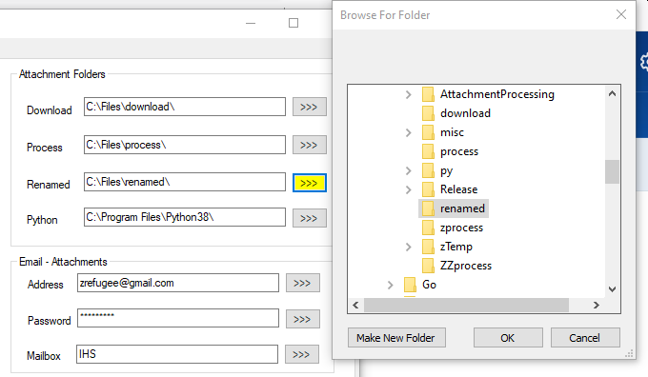

* Go to the “Attachment Processing” tab and set the date where any documents in the designated “Mailbox” (folder) on the date before and after the one set will be downloaded. Then click the “Download” button.

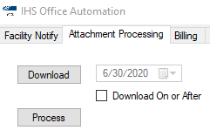

* After all the documents have been downloaded to “Settings -> Attachment Folders -> Download”, move all the files to “Settings → Attachment Folders -> Process”

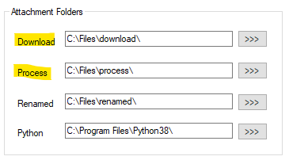

* After moving the files, click the “Process” button in the “Attachment Processing” tab.

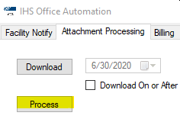

* After processing the files will be in the renamed folder (Settings ->Local Folders->Renamed) in the format “facility.pdf”, eg: 1F99999999.pdf. If you see a file like “02072020095642_1C99999999.pdf”, that means there was another file assigned to that facility account. On files like “INVALID1.pdf”, it means the program was not able to read the facility code and you need to rename it manually.

**Billing**

* It’s probably best to run the “Attachment Processing” functions first before going into the “Billing” tab since those documents will be needed to complete the billing process.
* For the reports to be assigned to a particular facility they need to have the facility group code set a prefix to the file name of the report. For example using“AIKEN(AI) CO DET CTR SC (SHP)”, the file name would something like “IHSBILLING_AI.rpt since the group code is “AI”. If the report use CIPS wholesale database. The format would be like “IHSBILLING_ZWS_AI.rpt” using the identifier in “Settings/Wholesale ID.



* The “Export Reports” function will go through the folder in “Settings -> Billing Reports” export them as PDF to “Settings -> Billing Exports”.

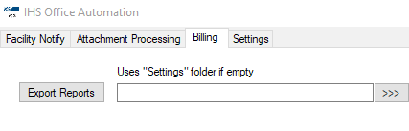

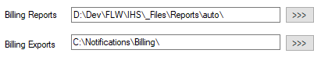

* The PDF documents created in the “Attachment Processing” process need to be copied to “Settings -> Billing Exports” folder before sending any emails to facilities but you can preview facilities in the “Documents Staged” grid before bringing the documents over.
* The “Get for Preview” button will load all facilities set up in database along account id numbers, assigned email addresses and documents for that facility in the “Settings -> Billing Exports” folder.

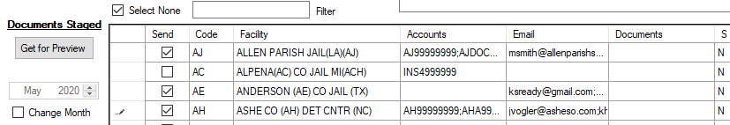

* All Accounts, Email addresses or Documents assigned to the facility can viewed by clicking on the cell
* 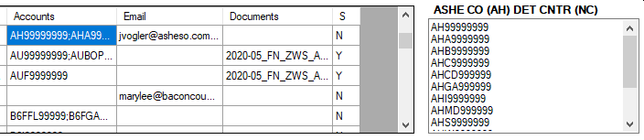The “Send Selected” button will send emails and documents for all facilities with the “Send” field checked or you double click on a row header to send a single facility.

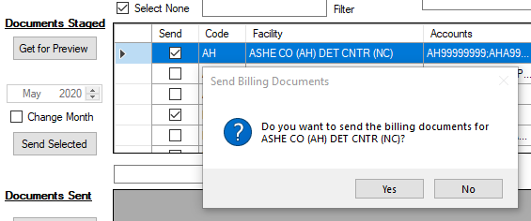

* In the “Documents Sent” grid you can view previously send emails by clicking the “Refresh” button.

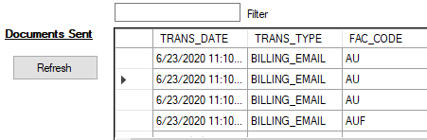

**Facility Notify**

* For ARX reminders, set the reminder date and click the “Import Notifications” button to load the calendar reminders, associated email addresses and fax numbers.

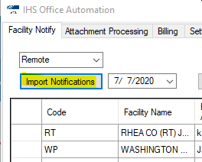

* Click the “Facility Export” button to create PDF files from the ARX report. If you want to view the documents before you send them they will located in the folder set in “Settings → Folders/Files → Notify Exports”. And the report used will be at “Settings → Folders/Files → Notify Report”.



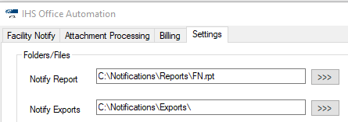

* Click the “Send Email” button to send reminders to all associated email addresses for the facility.



* Click the “Send Fax” button to send reminders by fax from the number assigned in CIPS.



**Setting Email Addresses**

* Go to <http://192.168.2.6:8001/login>

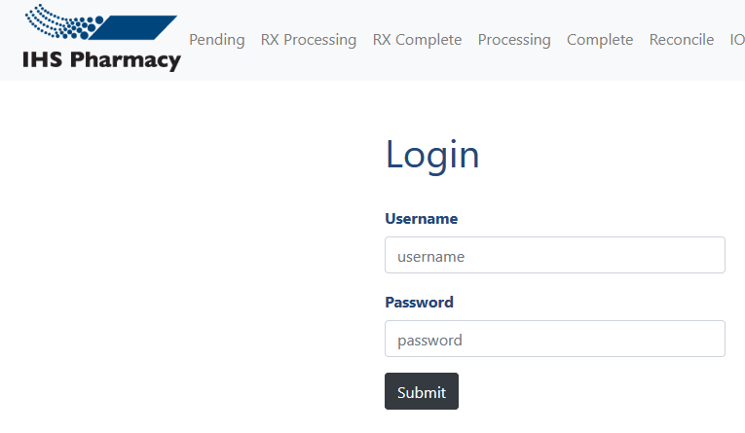

* Go to “Admin → Email Notifications”.

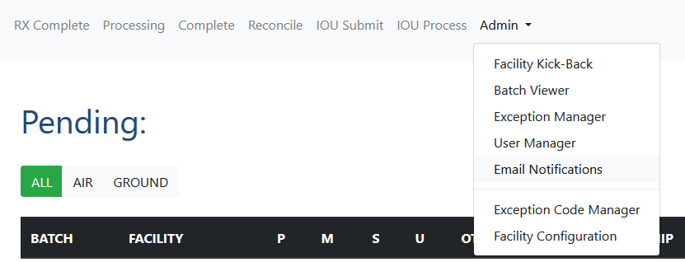

* Find the facility to add or edit an email address. An easy way to find the facility is to hold down Control and hit the letter “F”. This pop up a box to search the page. After you find the facility, click “Edit” to bring up the add/edit dialog.

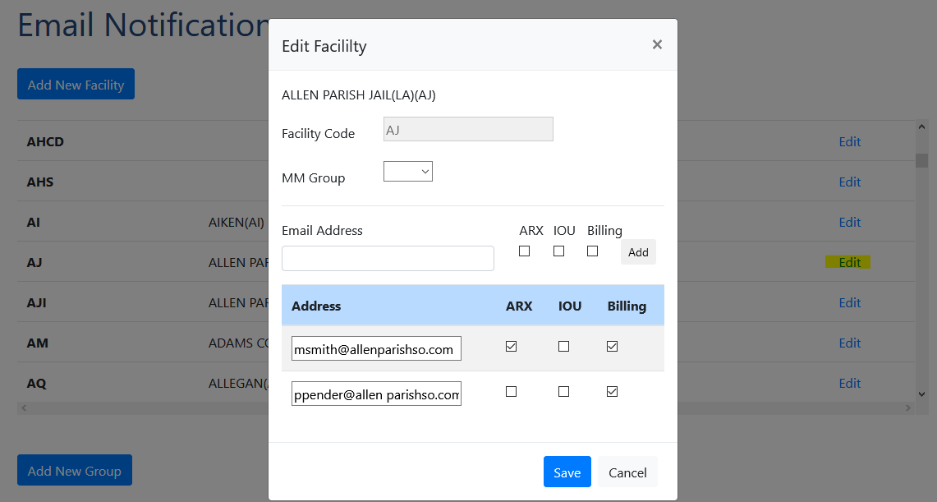

* After typing a new email address and selecting where it is used, click the “Add” button.
* After editing an existing email address, click “Save”.
* If the facility is not in the database click the “Add New Facility” and type in the facility group code. After it is created, you can start adding email addresses.

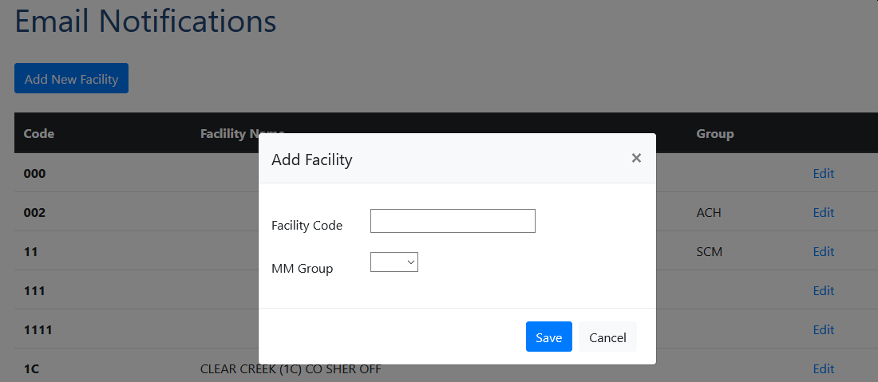

* Medical Management Groups can be assigned as well when adding a facility.
* Medical Management Groups can added and updated for IOU email notifications below the facility section.

